**Ex 9:Views**

create schema mydb;

use mydb;

create table Product(PID int,Pname varchar(10),cid int,price int);

desc Product;

insert into Product values(1,"cheese",1,30);

insert into Product values(2,"butter",1,29);

insert into Product values(3,"ckicken",2,40);

insert into Product values(4,"yum",7,5);

insert into Product values(5,"milk",3,10);

select * from Product;

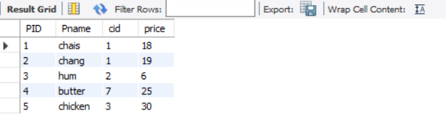

create view ProductAboveAveragePrice as select Pname,price from Product where price>(select AVG(price) from Product);

select * from ProductAboveAveragePrice;

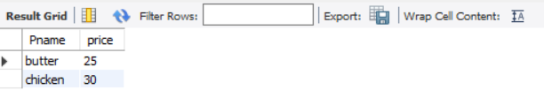

show create view ProductAboveAveragePrice;

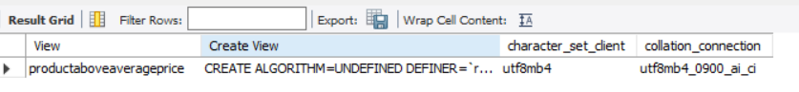

drop view ProductAboveAveragePrice;

